**Global Tool Configuration**

**Configure JDK:**

* Select add JDK
* Enter the name
* Copy the jdk path and paste at JAVA_HOME
* Click on apply and save

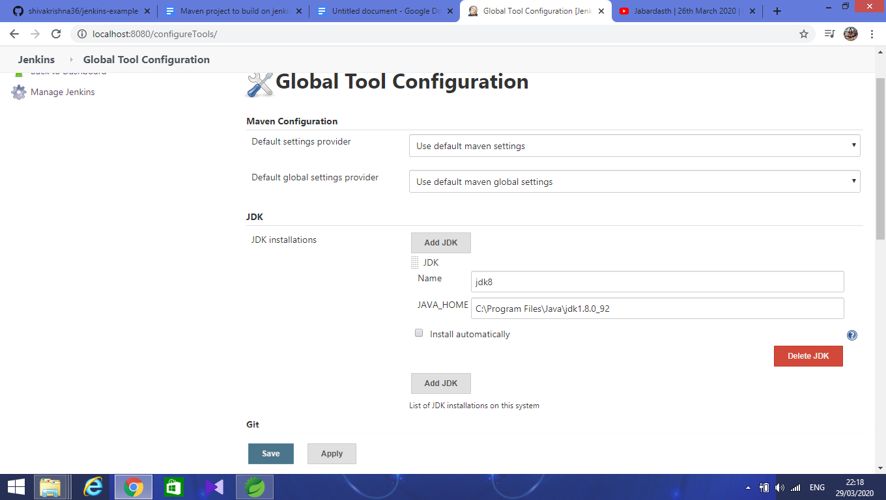

**Configure Git**

* Select git installations
* Enter the name
* Copy and paste the git path here
* Click on Apply and Save

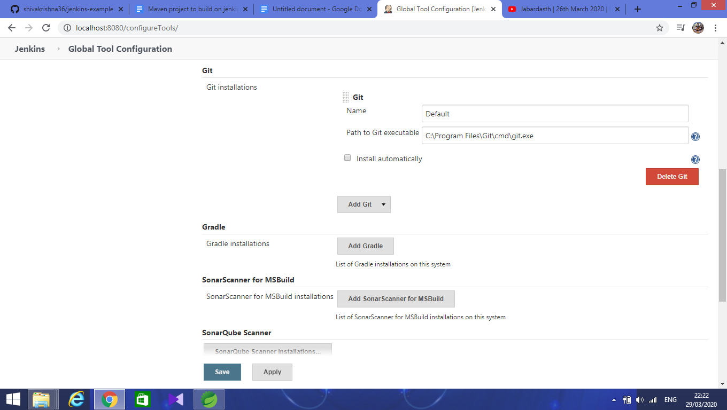

**Configure maven**

* Select maven installations
* Enter the name
* Copy and paste maven home path here
* Click on Apply and Save

